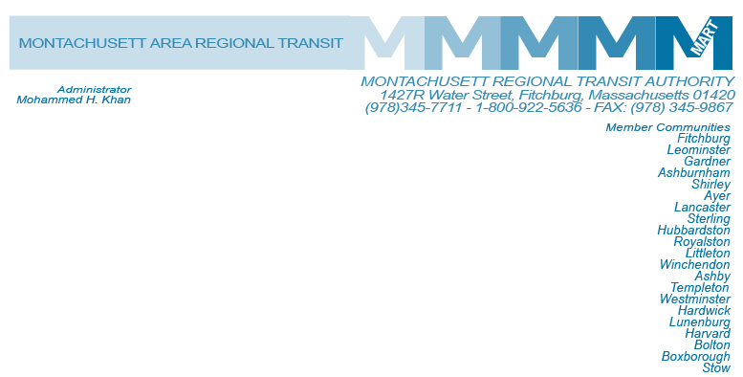

Posted 06/23/2016 at 2:38 pm by JAV

MART Maintenance Facility
1427R Water Street
Fitchburg, MA 01420

MEETING OF THE MART Executive COmpensation COmmittee

Wednesday, June 29, 2016
10:00 A.M.

Agenda

- Review Executive Salaries for Fiscal 2017
- Proposed Cost of Living Adjustment Including Executives Fiscal 2017
- Open Items
- Adjournment

